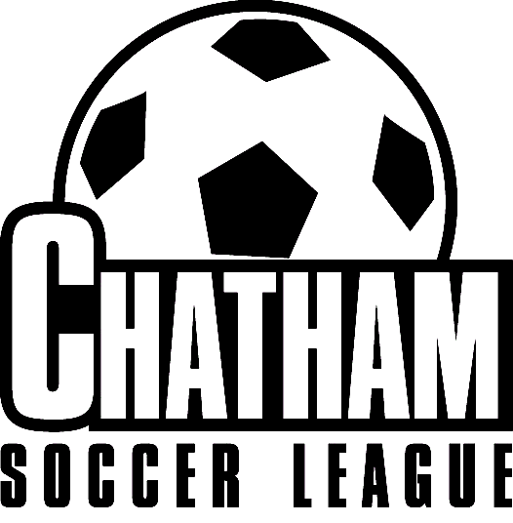
Support the
Chatham Soccer League effort to raise funds for
soccer field equipment.

- League logo on front; sponsor’s logo on back. *
- Short sleeve, high quality shirts. $12 each
- Four colors: Red or royal blue with white logo, bright pink or yellow with
navy logo.
- Youth and adult sizes.
- Mail order form and payment by check to:
Angel Dennison, P. O. Box 523; Pittsboro, NC 27312
- Make checks payable to Chatham Soccer League.
- Orders will be available for pick up at the Pittsboro Elementary School soccer field.
You will be notified by email (or by phone, if no email address) when your order is ready, usually seven to ten days.
- Questions? Contact Angel Dennison at pborofamily@earthlink.net

Chatham Soccer League T-shirt Order Form

Name: Daytime Phone Number:
Email address:
Team and Coach’s Name:

Number of shirts: X $12 per shirt = $ Amount Due with order.
(NOTE: If ordering through the mail, payment MUST BE by check payable to Chatham Soccer League.)

 | Youth  Small | Youth Medium | Youth Large | Adult  Small | Adult Medium | Adult  Large | Adult  X-Large | Total Quantity
Red

Royal Blue
Yellow

Pink

Total Quantity

* Sponsored by Carolina Meadows
Order Received: Delivered:

